ALDBURY PARISH COUNCIL WARDENS UPDATE: APRIL 2024

AREA | ALLOTMENTS & MILLENNIUM ORCHARD
TO CHECK | Fencing & gates, benches, trees, hedges & shrubs, grass height, signs, footpaths, housekeeping, ground conditions
INSPECTION DATES | 05/04, 12/04,21/04, 26/04, 04/05
ISSUES TO REPORT | - All fences, gates, and benches were found in sound condition, apart from an allotment gate, whereby adjustment was needed to enable the gate to be shut properly.  - Perimeter hedges and shrubs remain tidy despite recent spring growth.  - Grass is at a suitable height. Paths are well marked out in the orchard. Public footpath waymarkers were found in place.  - Trees were seen in good condition, with many fruit trees seen in full blossom.  - Generally, plots seem well managed with good housekeeping evident.

AREA | PLAYGROUNDS
TO CHECK | Equipment, Safety Information, Fencing & Gates, Benches, Trees, Grass height, General ground conditions, Empty litter bin.
INSPECTION DATES | 05/04, 12/04,21/04, 26/04, 04/05  Tring Station 15/04, 30/04
ISSUES TO REPORT | - User information signage was in situ and legible at both playgrounds.  - Timber play structures at the TS playground are showing signs of decay. In numerous areas, timber has either become sodden, disintegrated, or detached (photos 1, 2, 3, and 4). From visual inspection alone, it is not possible to establish if structural strength is becoming seriously weakened. It was recently agreed that APC will wait for the upcoming RoSPA’s inspection/report before deciding what action may be needed..  - Grass has recently been mowed at both playgrounds.  - Litter bin at Aldbury Playground was emptied on the 21st of April.  - Fences were in reasonable condition. Entrance gates were functioning correctly at both playgrounds.  Outstanding Items  - A replacement information sign is needed at TS playground. As previously, the sign should specify ownership, including contact details for visitors who wish to report faults/concerns/incidents to APC.  - A plastic steering wheel is wobbly on the play train at TS playground and requires tightening.

AREA | RECREATION GROUND
TO CHECK | Tennis court, Basketball area, Pavilion, Fencing, Benches/seats, Bollards, Trees & vegetation, Grass height, car park, Litter & dog waste bins, Footpaths.
INSPECTION DATES | 05/04, 12/04,21/04, 26/04, 04/05
ISSUES TO REPORT | - New car parking bays have been marked out. Twenty-three bays in total. Positive response from users (Photo 5).  - Grass is being mown and complies with the mowing specification.  - Litter picking was undertaken weekly. Litter levels remain low. A recent community litter pick proved successful.  - Algae/moss is discernible on the tennis court. Continue to monitor.  - A new footpath has been installed by the side of the sports pavilion (Photo 6). Former designated footpath is now fenced off.  Outstanding items  - The basketball area surface is uneven. First weed spray was done, may need a second one. A risk assessment might be advantageous towards determining if further maintenance/repair is necessary.

AREA | VILLAGE GREEN(S) & POND
TO CHECK | Benches, Trees, Pond, Grass height, Stocks, Litter Bins, Notice board.
DATES | 05/04, 12/04,21/04, 26/04, 04/05
ISSUES TO REPORT | - Grass has been mown and complies with the APC mowing specification.  - Weekly litter picking was carried out. Low levels of litter.  - Benches were found in fair condition.  - No defects were discernible on the trees i.e. detached branches.  - Notice board information is up to date.
AREA | HIGHWAY’S, PUBLIC FOOTPATHS & DITCHES
TO CHECK | Surfaces, Pedestrian routes, Signage, Drainage, Grit bins, Litter, Street lamps, Bollards, kissing gates, Notice board (Tring Station)
DATES | 05/04, 12/04,21/04, 26/04, 04/05
ISSUES TO REPORT | - All streetlamps were functioning correctly during the evening of the 29th of April.  - In addition to a recent community litter pick, regular litter picking was undertaken throughout the village, covering Stocks Road (to the walled garden), New Ground Road (to the former isolation hospital), Station Road (to railway station bridge), Malting Lane, Stonycroft and Toms Hill.  - Pleasingly, the condition of public footpaths around the parish is slowly improving.  - Three large potholes in New Ground Road were repaired by HCC. Ref No: 401004060877.  - HCC have decided to repair a deep pothole near the Church Farm entrance by the 14th of May. Ref no: 401004120916 (Photo 7). The pothole has proven problematic to road users, notably cyclists.  - A timber kissing gate (FP 60) is in a fragile condition (Greening Farm Lane). DBC are alerting the responsible landowner (Photo 8).  - After a lengthy delay, HCC have decided that replacement of missing/faded road markings at the Stonycroft/Trooper Road junction is currently not a priority – seemingly a decision reached without a site visit. In response, the Parish Clerk is contacting Cllr Symington for assistance. Members will be aware this is a long-standing local concern mentioned in the Aldbury and Tring Station Community Survey 2021. HCC Ref No: Ref No: 401003875518.  Outstanding Items  - A tree has fallen across an open drain/ditch (south of Stonycroft). The tree is obstructing the free flow of water (Photo 9). It is understood the landowner has been notified twice but no action was taken yet. The Clerk will contact them again.  - Blocked drains/gullies situated in Malting Lane (x 2), Station Road (opposite the church) and Stocks Road (near Applegarth). HCC ref No’s 401003990129, 401003990131, 401003990125 and 401003990137 respectively. HCC have added the drains to the scheduled drain unblocking programme.
PHOTOGRAPHS
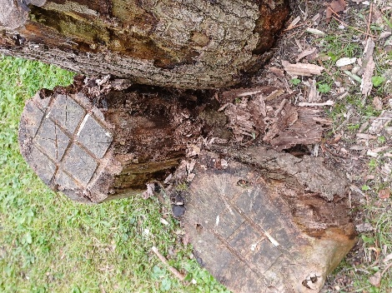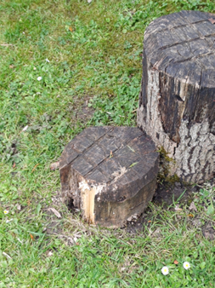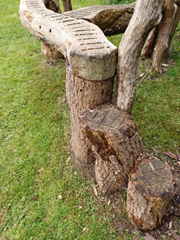
1
3
2

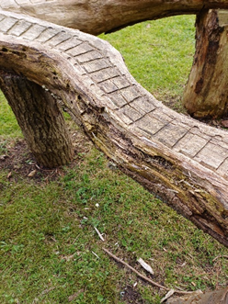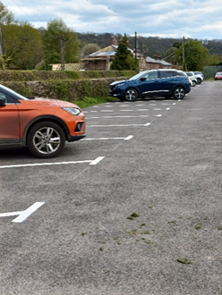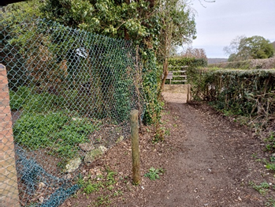
6
5
4

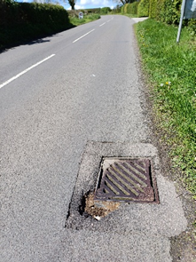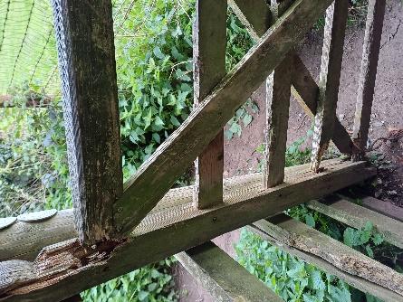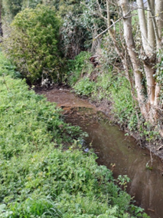
8
9
7

